College of Arts and Science
The Arts and Science staff Network Board serves as a channel of communication among members of the non-academic staff in the College of Arts and Science, as an advisory group to the Dean of the College, and as a liaison to similar groups outside the college. The Network strives to develop non-academic staff as a human resource; to enhance cooperation and the exchange of information; to foster continued education and professional development; and to serve as a representative body making known the interests of the staff.
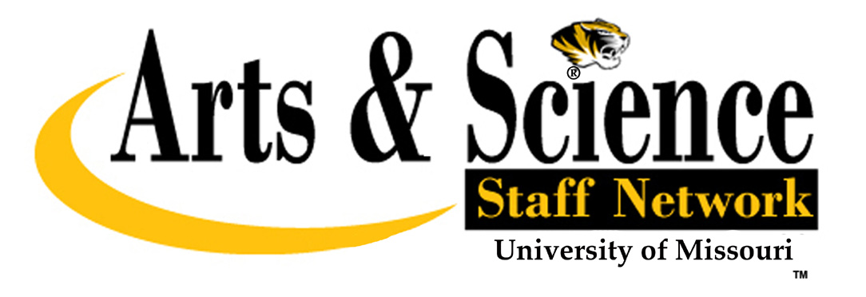

Staff Appreciation Award
Nomination Form

Nominee_________________________________ Title_________________________________________

Department _______________________________ Dept. Phone #_________________________________

Address__________________________________

Nominator________________________________ Title_________________________________________

Department_______________________________ Dept. Phone #_________________________________

Address__________________________________

________________________________________ _____________________________________________
Nominator’s Signature Date

Please detail below the characteristics that you believe sets the nominee out as exceptional.

Performance - Give examples of exceptional performance, productivity, initiative demonstrated by nominee.

Collegiality - Describe nominee’s interactions with co-workers and others in the university community.

Dedication - Give examples of nominee’s commitment to the mission and values of the university.

Character - Provide evidence of nominee’s dependability, judgment and principles.

Contact Kelly J. Davis daviskel@missouri.edu if you need additional information.
Send completed application to: Kelly J. Davis, 208 McAlester Hall, Psychological Sciences
Deadline for Nominations is March 20, 2013

